**DAIRY MANAGEMENT SYSTEM**

A project submitted to

**UKA TARSADIA UNIVERSITY**

in partial fulfilment of the requirements for the degree of

**Bachelor of Science in Information Technology**

**for**

**5 Years Integrated M.Sc.(IT)**

for 4th Semester

by

**Deep Tallewar**

**(201806100110104)**

**Khushboo Bajaj**

**(201806100110112)**

Guided by

**Mr. Bhavik Sarang**

**Assistant Professor**



Babu Madhav Institute of Information Technology

Uka Tarsadia University,

Bardoli – 394350

April 2020

**CERTIFICATE**

Date: /04/2020

This is to certify that **Mr. Deep Tallewar (enro.: 201806100110104), Miss. Khushboo Bajaj(enro.: 201806100110112),** students of class S.Y. Five Year Integrated M.Sc.(IT) semester IV had submitted self-creation project entitled “Dairy Management System” in subject 060010413 - CC13 Software Engineering as per Uka Tarsadiya University curriculum for the academic year 2019-20.

|  |
| --- |
| *External* Examiner  Subject Teacher |



**AKNOWLEDGEMENT**

WE WOULD LIKE TO EXPRESS OUR SPECIAL THANKS OF GRATITUDE TO OUR SOFTWARE ENGINEERING SIR “MR. BHAVIKSARANG” FOR THEIR ABLE GUIDANCE AND SUPPORT TO COMPLETING MY PROJECT.

WE WOULD LIKE TO EXTEND OUR GRATITUDE TO OUR HEAD OF DEPARTMENT SIR “MR JITENDRA NASRIWALA” FOR PROVING US WITH ALL THE FACILITY THAT WAS REQUIRED.

|  |  |
| --- | --- |
| **Title of Project** | Dairy Management System |
| **Stakeholders** | Admin, Staff and Seller |
| **Techniques used for requirements capturing** | Interviewing and Questionnaire |
| **Name of the persons along with designation** | - |
| **Date** | April, 2020 |
| **Version** | 1.0 |

|  |
| --- |
| **Consolidated list of Initial Requirements**   * System is to be built which can run on your dairy’s LAN. * Barcode Reader used for easy purchase and selling of dairy products. * System shall generate OTP for authentication of person before sign-up. * How many members will be using the system? * Who will be maintaining the product stock? * Who will be able to view the stock? * Who will look after the purchase of product? • Who will look after the selling of Product? * Will system be showing the availability of product? * Will system be showing availability of number of units for particular product? * Will customer be able to use credit/debit cards and online payment methods for payment? * Will it be possible for Customer to give feedback? * Will customer will able to report on system for any inconvenience? * System should generate reports like : * Details of Product   + Product-wise.   + Company-wise.   + Price-wise.   + Quality-wise. * Details of whole Staff * Status |

**INTIAL REQUIREMENTS DOCUMENT**

**Table of Content**

|  |  |  |  |  |
| --- | --- | --- | --- | --- |
| **Chapters** | **Particulars** | | | **Page no.** |
| **1** | **Introduction** | | |  |
| 1.1 | Purpose | |  |
| 1.2 | Product Scope | |  |
| 1.3 | Problem Definition | |  |
|  | | | | |
| **2** | **Overall Description** | | |  |
| 2.1 | Product Perspective/ Environment Description | |  |
|  | 2.1.1 | Hardware Interface/ Hardware Specification |  |
|  | 2.1.2 | Software Interface/ Software Specification |  |
|  | 2.1.3 | Communication Interface |  |
| 2.2 | User Characteristics | |  |
|  | | | | |
| **3** | **System Planning** | | |  |
| 3.1 | Software Engineering Model | |  |
|  | | | | |
| **4** | **System Specific Requirements** | | |  |
| 4.1 | Functional Requirement | |  |
| 4.2 | Non-functional Requirement | |  |
|  | | | | |
| **5** | **System Analysis** | | |  |
| 5.1 | Use case Diagram(s) | |  |
| 5.2 | Activity Diagrams | |  |
| 5.3 | Sequence Diagrams | |  |
|  | | | | |
| **6** | **System Design** | | |  |
| 6.1 | Database Design | |  |
| 6.1.1 | Database Schema |  |
| 6.1.2 | Data Dictionary |  |
|  | | | | |
| **7** | **System Implementation** | | |  |
| 7.1 | Screenshots | |  |
|  | | | | |
| **8** | **Testing** | | |  |
| 8.1 | Test Cases | |  |
|  | | | | |
| **9** | **Future Enhancement** | | |  |
|  |  | | |  |
|  | **Conclusion** | | |  |
|  |  | | |  |
|  | **Bibliography** | | |  |

**List of Figures**

|  |  |  |
| --- | --- | --- |
| **Figure no.** | **Figure Description** | **Page no.** |
| **5.1.1** | **Use Case Diagram for Admin** |  |
| **5.1.2** |  |  |
| **5.1.3** |  |  |
| **5.2.1** | **Activity Diagram for Manage Product** |  |
| **5.2.2** |  |  |
| **5.2.3** |  |  |
| **5.2.4** |  |  |
| **5.2.5** |  |  |
| **5.3.1** | **Sequence Diagram for “adding a product”** |  |

**List of Tables**

|  |  |  |
| --- | --- | --- |
| **Table no.** | **Table Description** | **Page no.** |
|  | Data Dictionary Tables | 50 - 60 |
| 8.1.1 | Test Cases for Login |  |
| 8.1.2 | Test Cases for Product |  |

**1.Introduction**

1.1 Purpose

The main objective of this application is to automate the complete operations of the Milk Distributor Office. They need maintain hundreds of thousands of records. Also searching should be very faster so they can find required details instantly.

1.2 Project Scope

This application is built such a way that it should suits for all type of Milk Distributors in future. So every effort is taken to implement this project in this milk Distributor Office, on successful implementation in this Milk Distributor Office, we can target other Milk Distributors in the city.

* 1. Problem Definition

When we Analysis the Manage about this firm then we face that they working with manual. And we all know that the manual system has many disadvantages. Some are mentioned below…

The manual system requires more time for processing. It requires more critical work. The manual system is more error prone. Difficult to maintain. Manual system is costly. – Immediate response to the queries is difficult and time consuming. – More men power needed. – Manual system show of the particular place.

**2. Overall Description**

* 1. Product Perspective

It is a desktop based application which provide admin to see all the transaction happening in farm. Staff may be able to register the user or may able to update delete or search data as per required.

|  |  |
| --- | --- |
| PROCESSOR | 1.60GHZ |
| RAM | 512 MB |
| HARDDISK | 40GB |

Hardware

Specification

* New system is required because of some advantage of new system are as below…
* The new system required less time for completion of any work. – New system is decreasing the chances of error. – New system should work smoothly and very fast. – New system saving time and manpower. – The system is user friendly and anyone having computer knowledge can handle it easily. – Suitability for computerized data entry. Maintaining Dairy information, Staff information & Customer information, Milk Rate Information.

|  |  |
| --- | --- |
| MICROSOFT VISUAL STUDIO | VERSION 2010 |

Software Specification

Communication Interface

* We are using simple electronic form to register update delete or search data according to the data required.

User Characteristics

* Front-end software: visual studio
* Back-end software: MySQL

**3.System Planning**

3.1 Software Engineering Model

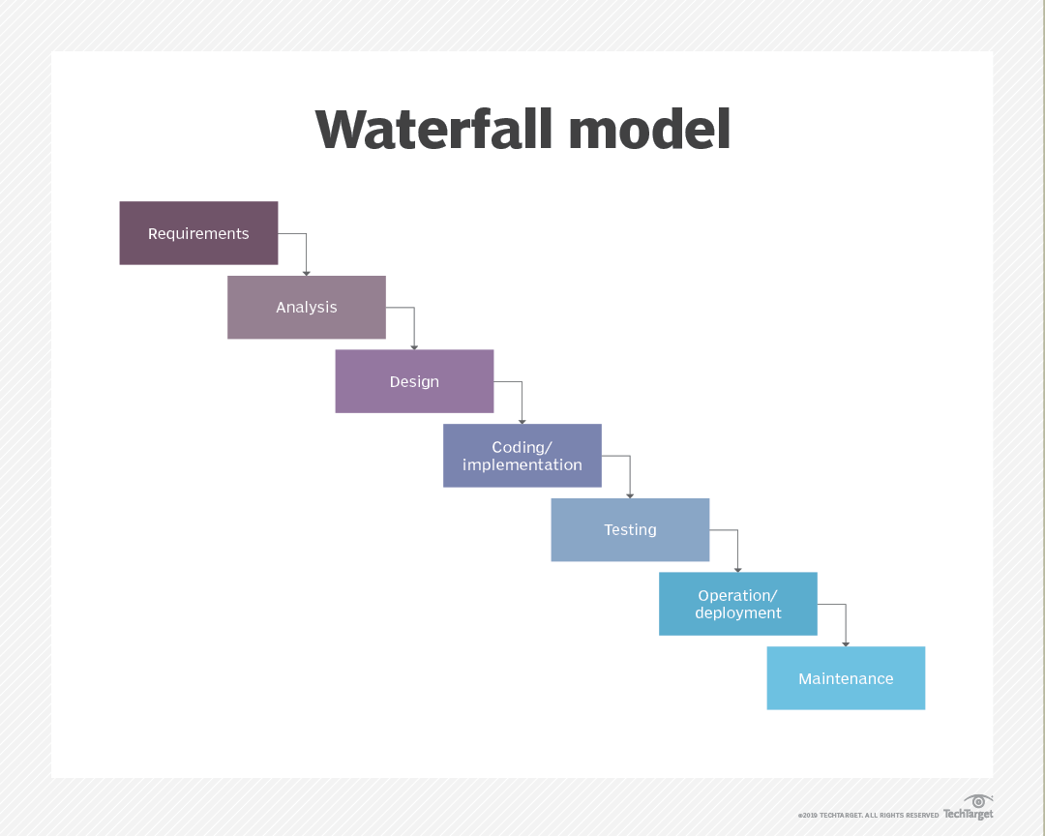

Thewaterfall method is selected for developing this software. As the major problem of the system were gathered at the beginning and were able to define clearly.

Generally it has 7 phase:

1)Requirement

2)Analysis

3)Design

4)Coding/implement

5)Testing

6)Operation/deployment

7)Maintenance

* **Requirement Gathering and analysis** − All possible requirements of the system to be developed are captured in this phase and documented in a requirement specification document.
* **System Design** − The requirement specifications from first phase are studied in this phase and the system design is prepared. This system design helps in specifying hardware and system requirements and helps in defining the overall system architecture.
* **Implementation** − With inputs from the system design, the system is first developed in small programs called units, which are integrated in the next phase. Each unit is developed and tested for its functionality, which is referred to as Unit Testing.
* **Integration and Testing** − All the units developed in the implementation phase are integrated into a system after testing of each unit. Post integration the entire system is tested for any faults and failures.
* **Deployment of system** − Once the functional and non-functional testing is done; the product is deployed in the customer environment or released into the market.
* **Maintenance** − There are some issues which come up in the client environment. To fix those issues, patches are released. Also to enhance the product some better versions are released. Maintenance is done to deliver these changes in the customer environment.

Some of the major advantages of the Waterfall Model are as follows −

* Simple and easy to understand and use
* Easy to manage due to the rigidity of the model. Each phase has specific deliverables and a review process.
* Phases are processed and completed one at a time.
* Works well for smaller projects where requirements are very well understood.
* Clearly defined stages.
* Well understood milestones.
* Easy to arrange tasks.
* Process and results are well documented.

**4.System Specific Requirement**

4.1 Functional Requirement

Admin

* Login
* Manage Product Rate
* Manage Staff
* Manage Members

Staff

* Login
* Seller Registration
* Manage Product 
* Manage Feedback 
* Insert Product 
* Seller Bill Generation

4.2Non-Functional Requirement

* Access Security
* Accessibility
* Confidential
* Efficiency
* Safety

**5. System Analyst**

**5.1 Use Case Diagram**

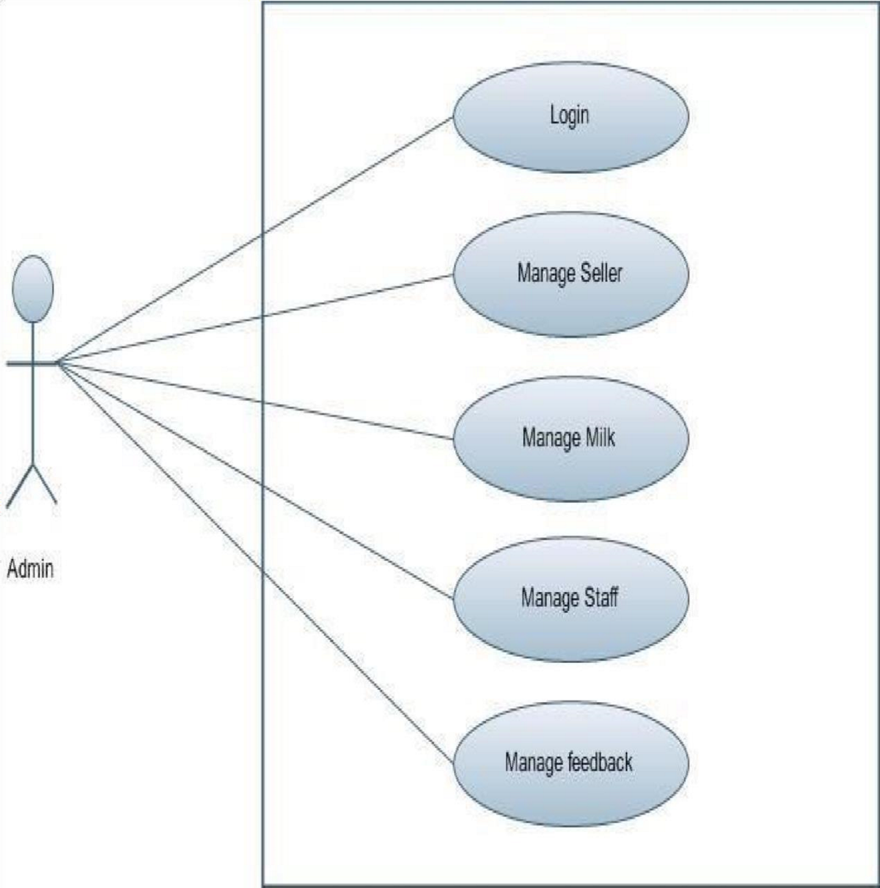

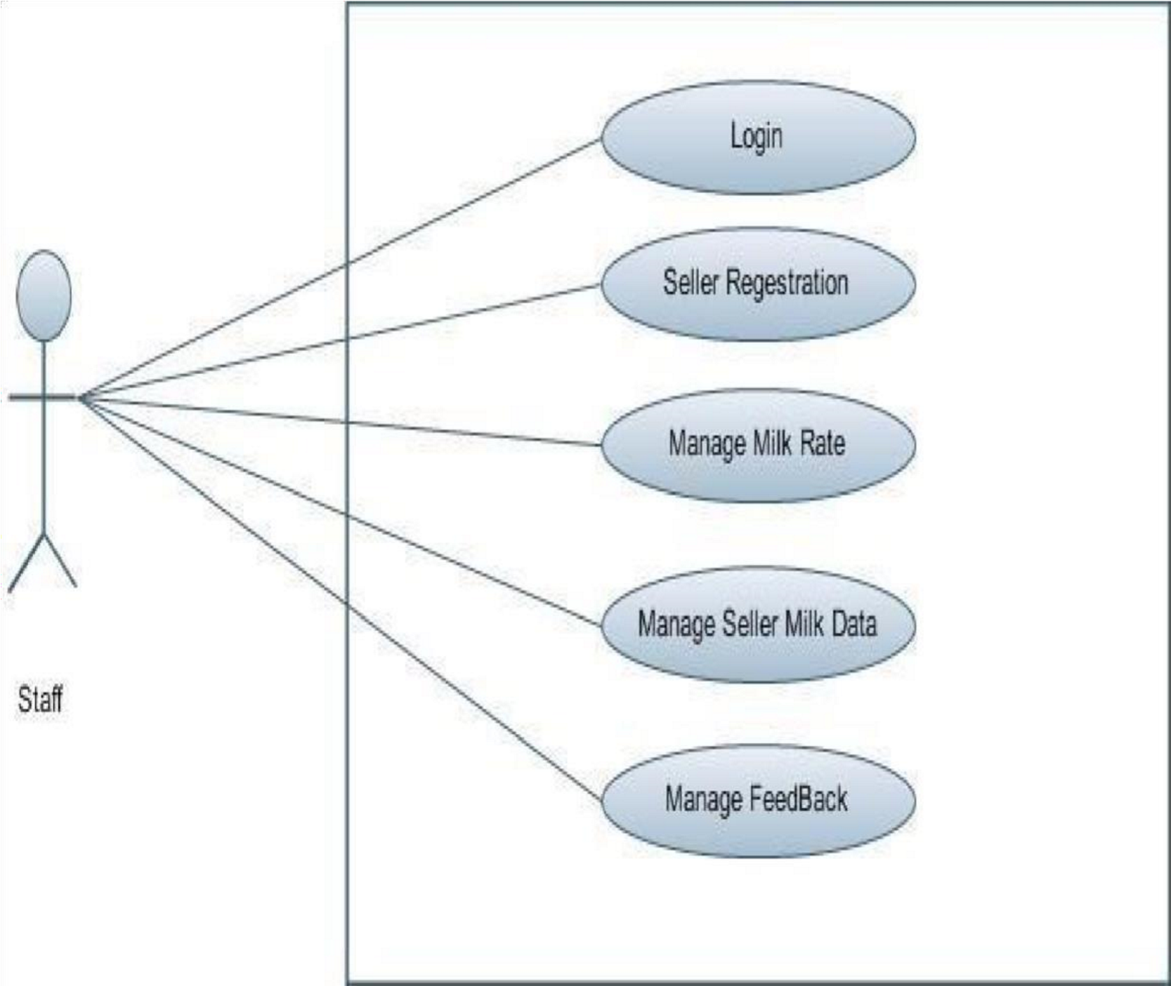

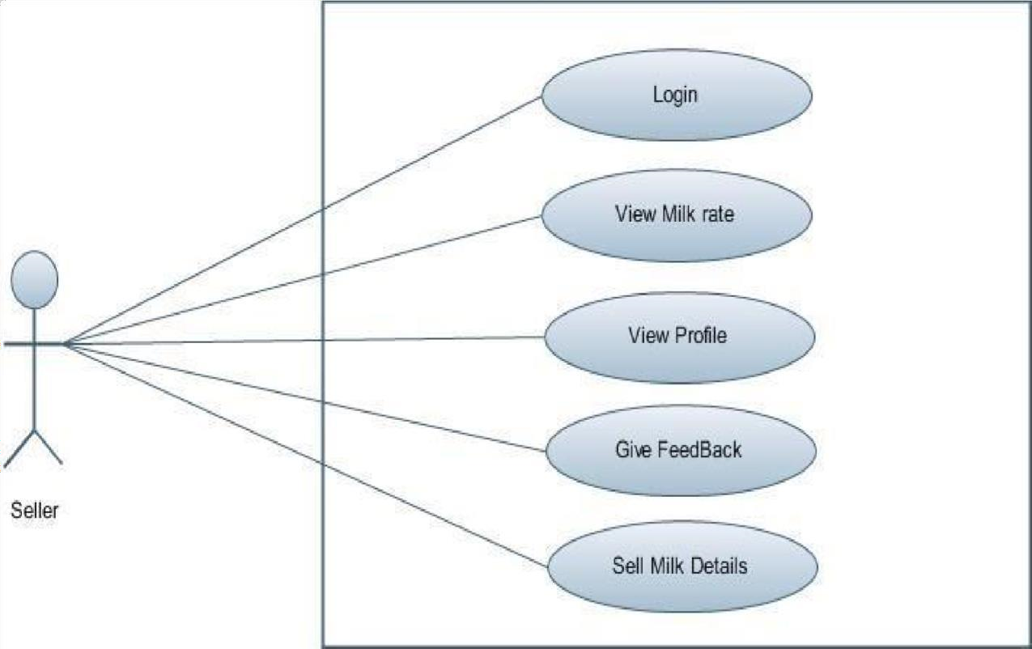

**5.2 Activity Diagram**

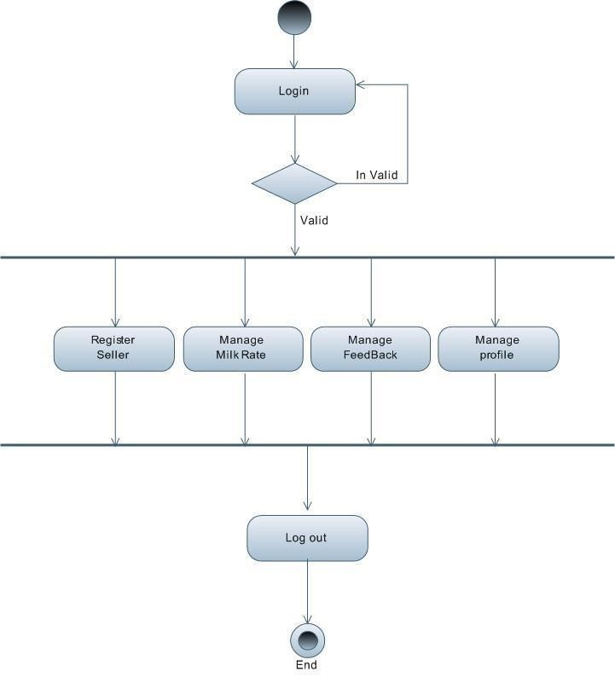

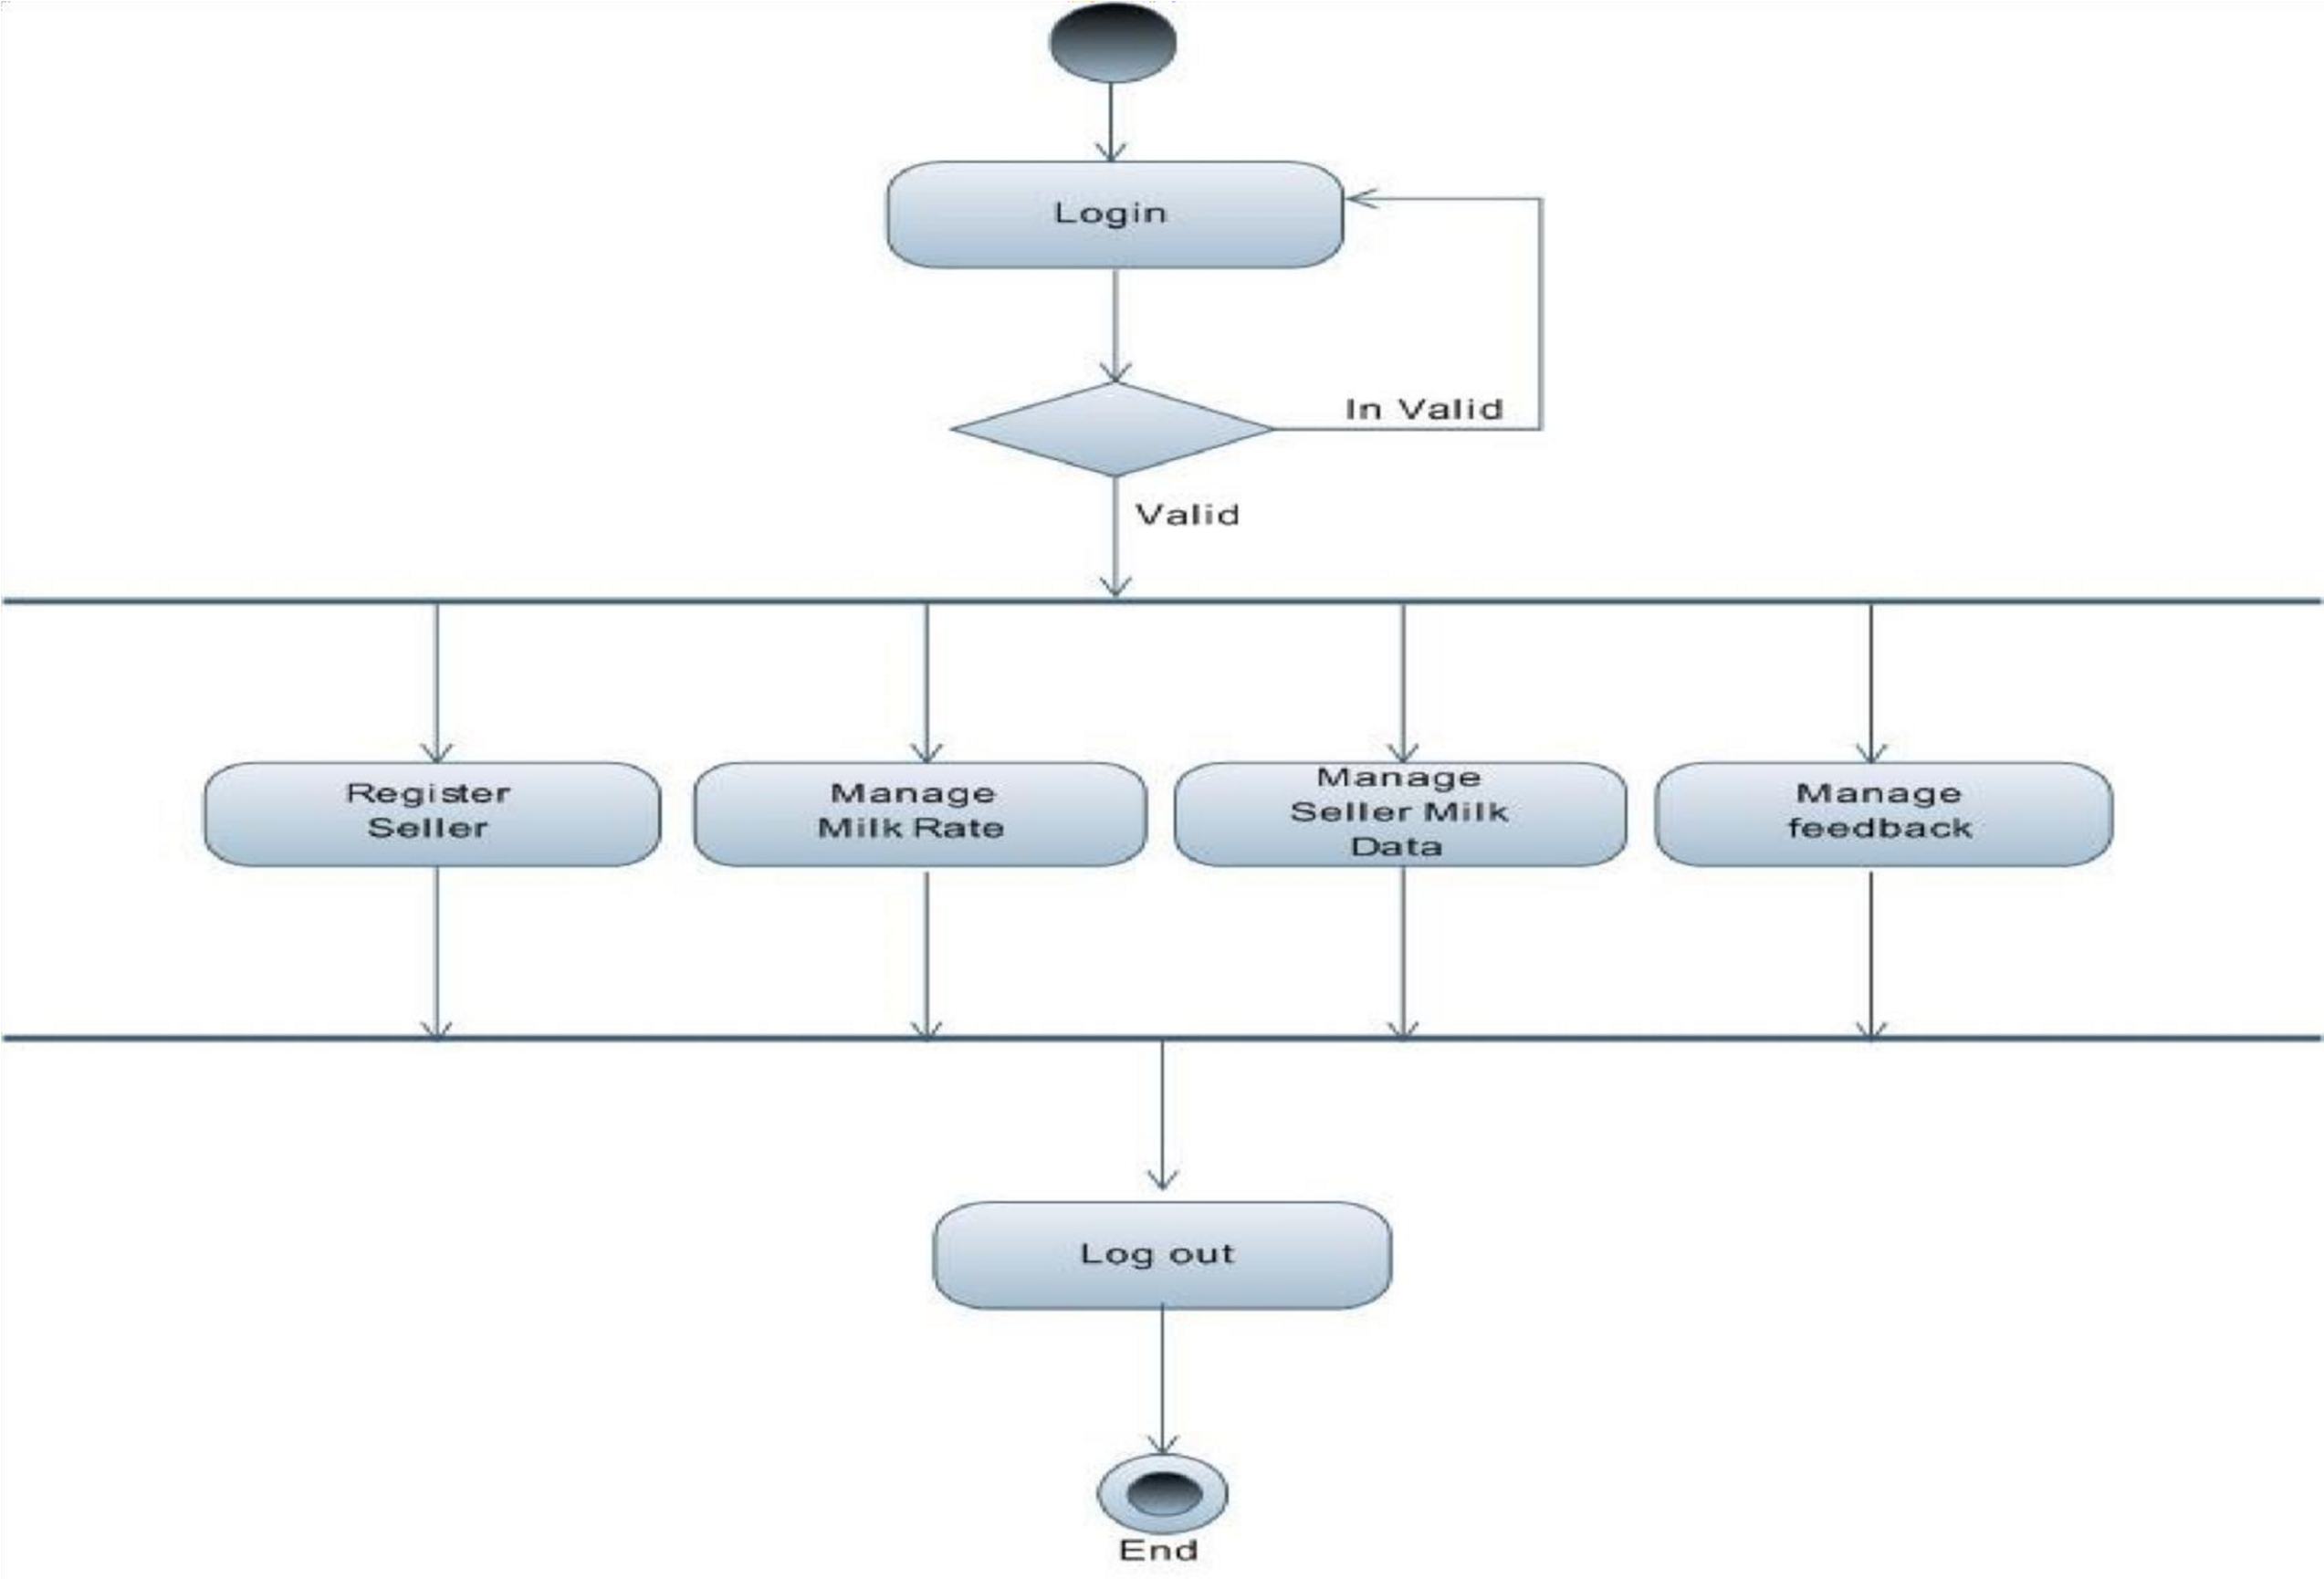

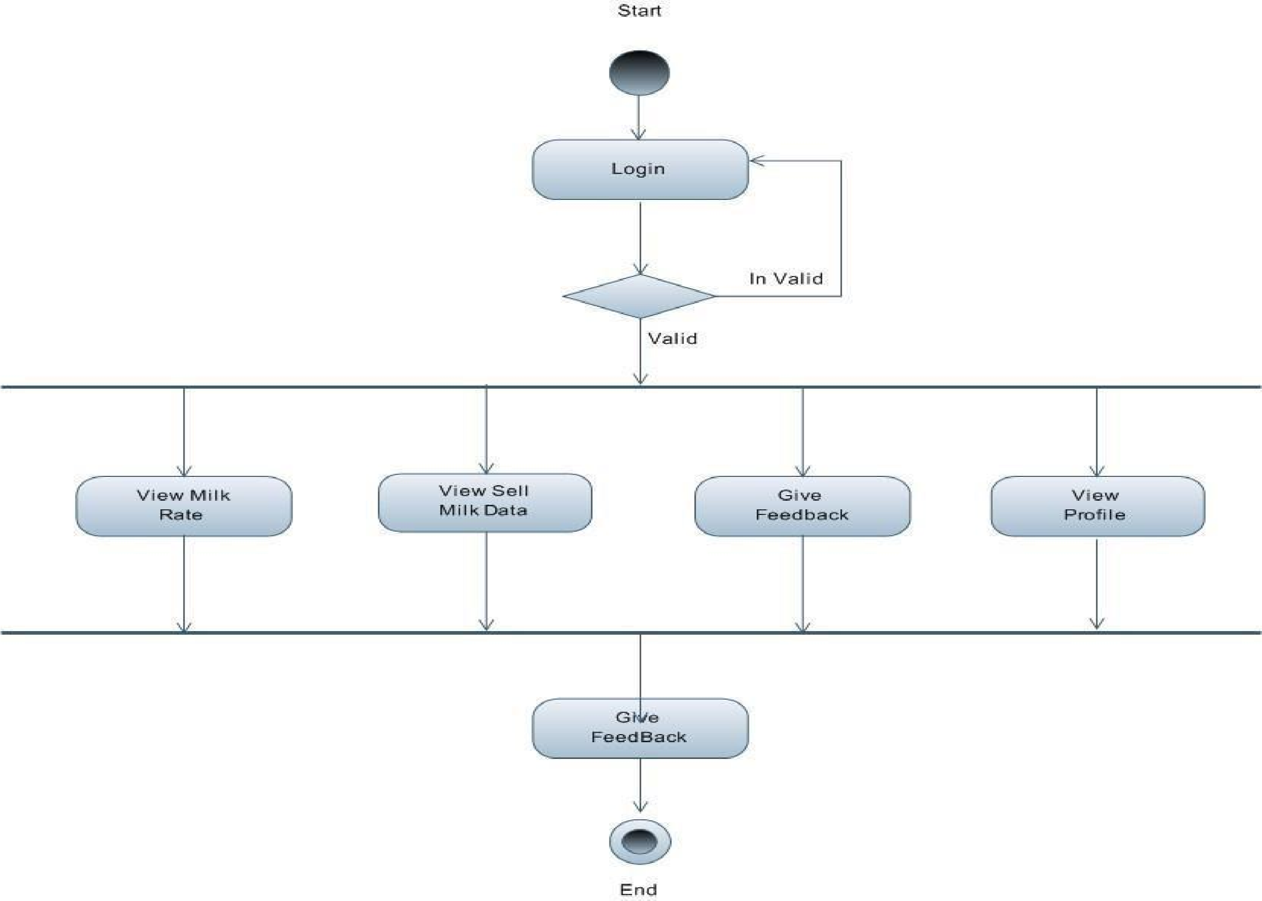

**5.3 Sequence Diagram**

Sequence Diagram for Admin

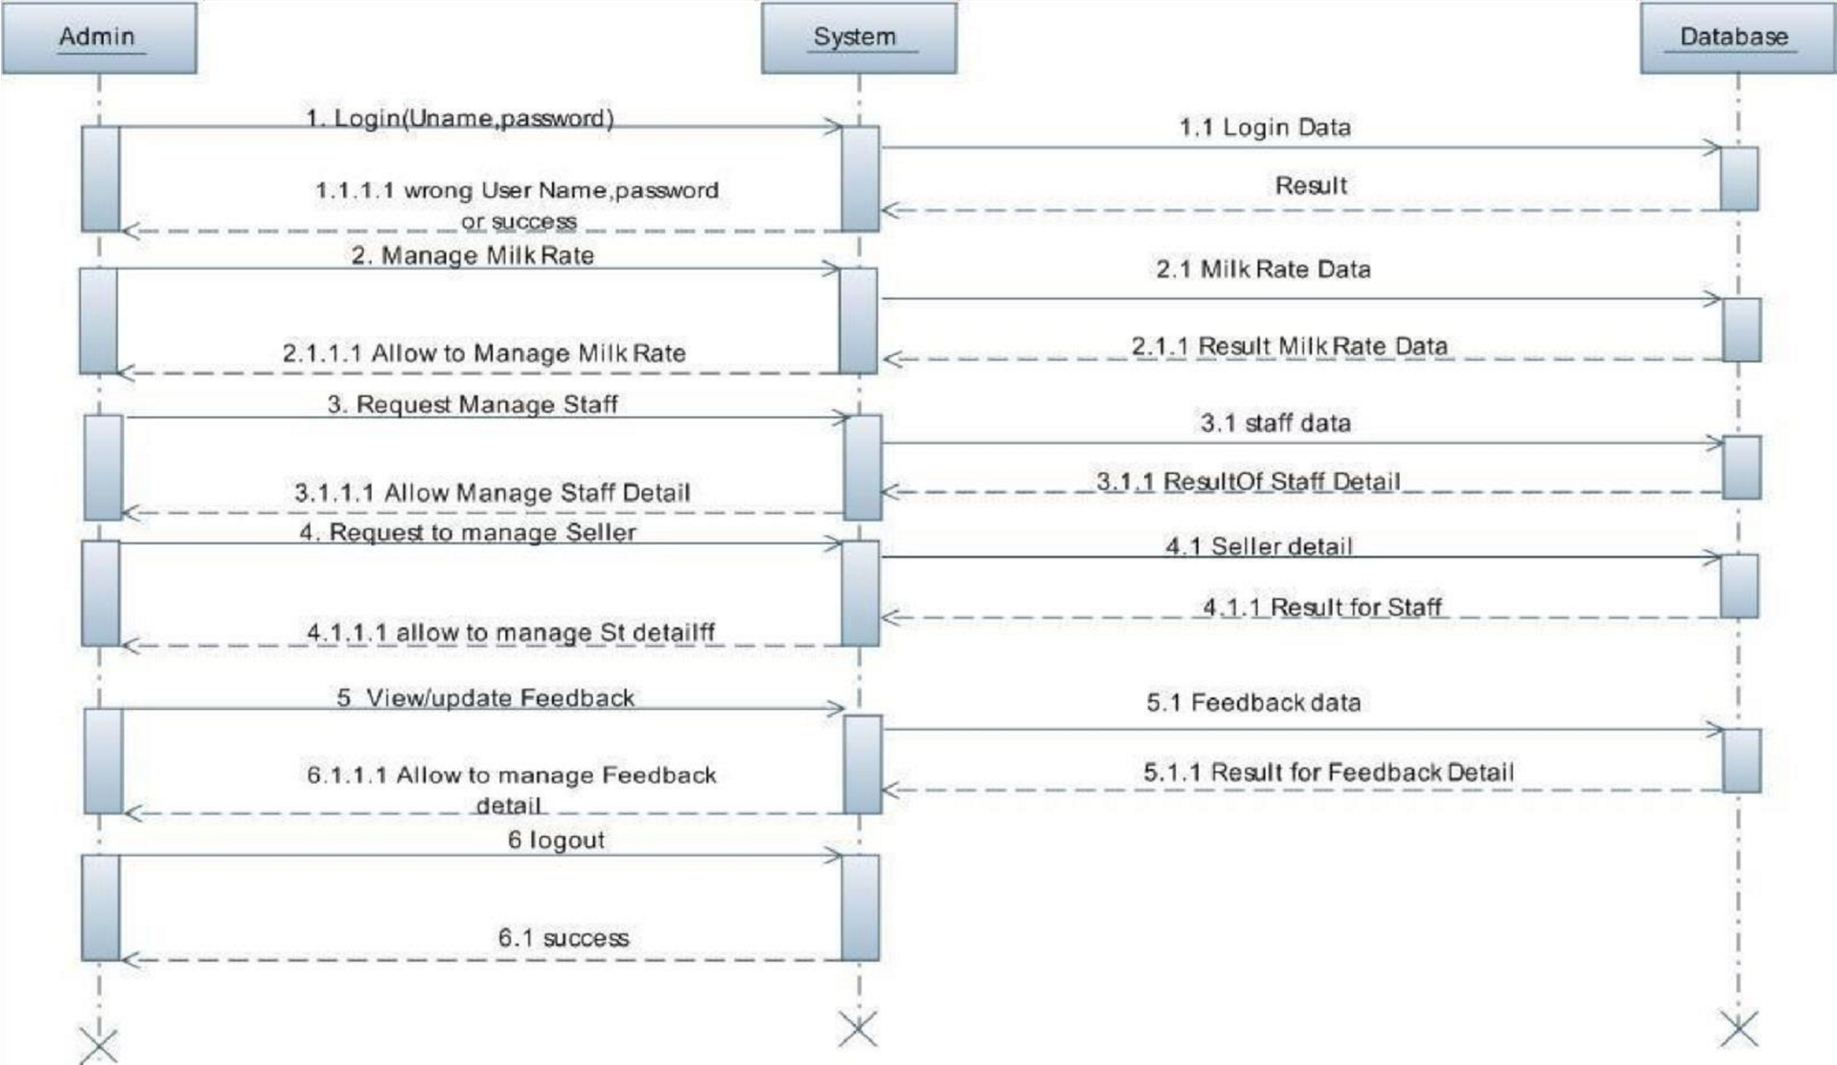

Sequence Diagram for Staff

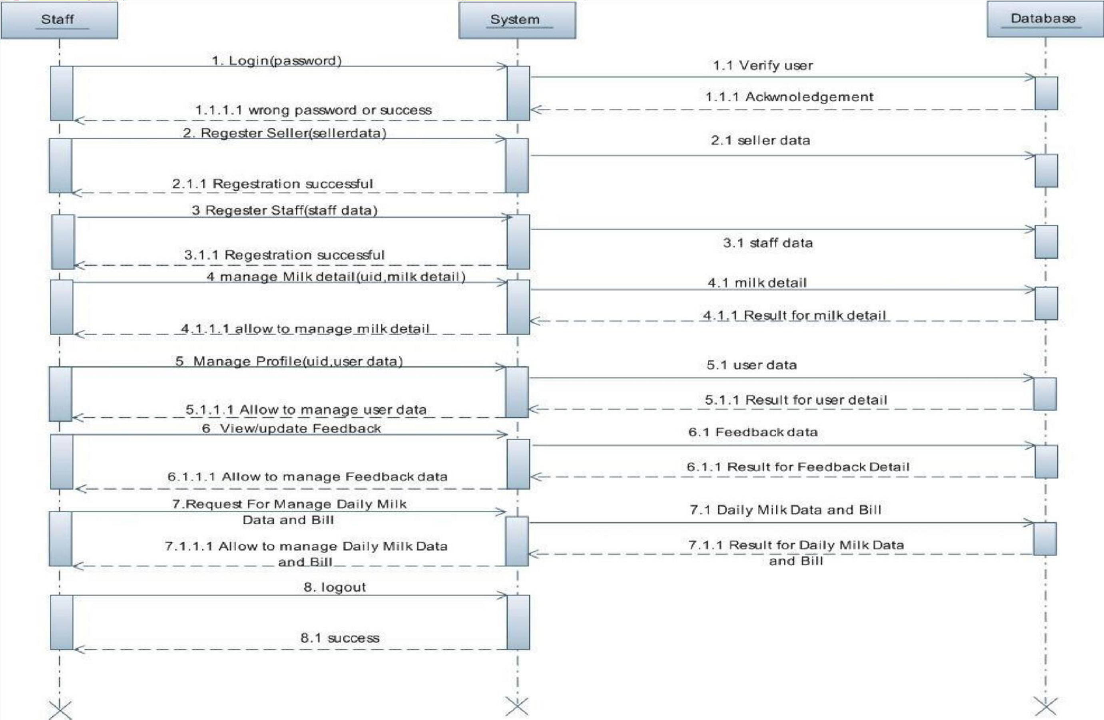

Sequence Diagram for Seller

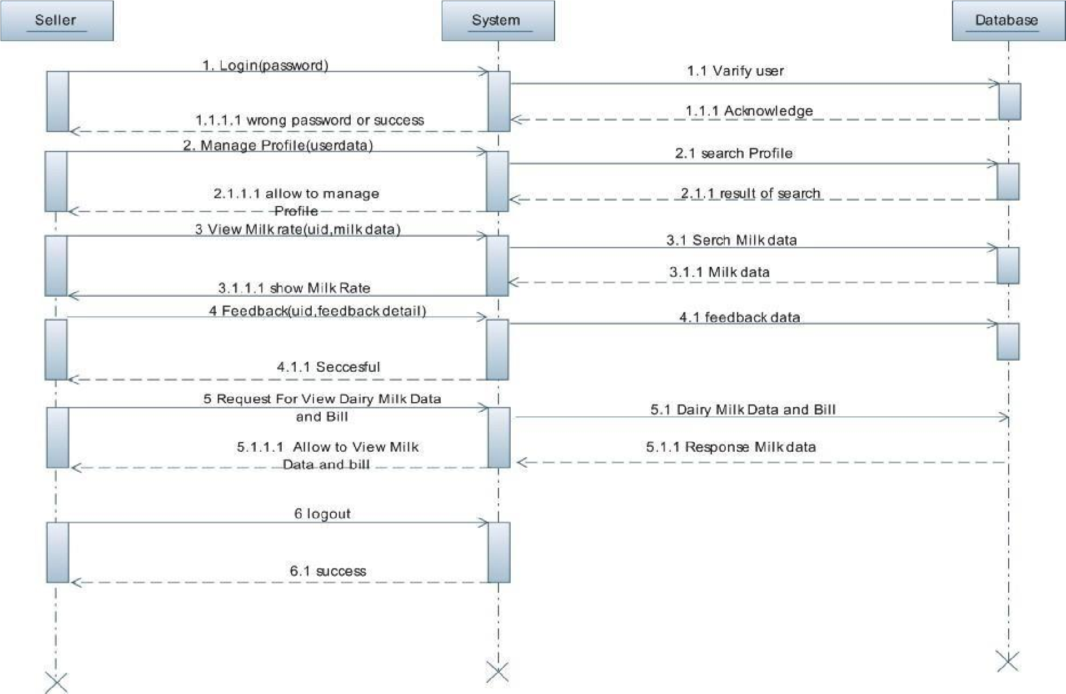

**6. System Design**

6.1 Database Design

6.1.1 Database Schema

Design

 Data schema 

|  |  |  |  |  |
| --- | --- | --- | --- | --- |
|  | Table login: tbllogin(user_id(primary key),password) FD: id->(password)  Table staff: tblstaff(s_no(primary key),name,gender,address,work,salary,phone_no,r_date) FD: s_no->(name,gender,address,work,salary,phone_no,r_date)  Milk rate table: tblmilkrate(fat,buffalo,cow,udate) FD:fat->(buffalo,cow,udate)  Table seller: tblseller(s_code(primarykey),user_id(foreignkey),s_name,address,ani_cattle,r_date,  sellmilk) FD:s_code->(user_id(foreignkey),s_name,address,ani_cattle,r_date,sellmilk)  Table feedback: tblfeedback(name,user_id(primarykey),address,taluka,district,phone_no,  email_address,feedback) FD:user_id->(name,address,taluka,district,phone_no, email_address,feedback)  Daily milk data table: daily_milk_rate(did(primarykey),user_id(foreignkey),quantity,cattle_type,fat, submit) FD: did->(user_id(foreignkey),quantity,cattle_type,fat, submit)  Table bill: tblbill(bid(primary key), user_id, total_quantity,total amount,bill_date) FD: bid->(), user_id, total_quantity,total amount,bill_date)   |  |  | | --- | --- | |  |  | |  |

 

Table Name :- Login Table

Primary Key :- User_Id

Description :- This table is use for stored User and Password

|  |  |  |  |
| --- | --- | --- | --- |
| **Filed** | **Type** | **Key** | **Description** |
| **Username** | Varchar(255) | Unique |  |
| **Password** | Varchar(255) |  |  |
|  |  |  |  |

**Table staff**

Table Name :- Staff Table

Primary Key :- S_Code

Description :- This table is use for stored Seller User Id,Seller

Code, Name,Address, Registration Date and Animal Cattle.

|  |  |  |  |
| --- | --- | --- | --- |
| **Employee_id** | int | Primary | auto_increment |
| **S_no** | Varchar(255) | Foreign | With Class Login |
| **S_name** | Varchar(255) |  |  |
| **Work** | Varchar(255) |  |  |
| **Salary** | Varchar(255) | Unique |  |
| **Gender** | Varchar(255) |  |  |
| **Phone_no** | Varchar(255) |  |  |
| **R_date** | Varchar(255) |  |  |

|  |  |
| --- | --- |
|  |  |

Milk rate table:

|  |  |
| --- | --- |
| Table name | :- Milk Rate Table |
| Primary Key | :- Fat |
| Description | :-This table is use for stored Fat,  Buffalo & Cow Milk  Rate, and Updated Date of the milk Rate |

|  |  |  |  |
| --- | --- | --- | --- |
| **Filed** | **Type** | **Key** | **Description** |
| **fat** | int | Primary  Foreign | auto_increment  With Payment table |
| **buffalo** | Varchar(255) | Foreign | With Class Login table |
| **cow** | Varchar(255) |  |  |
| **Update** | Varchar(255) |  |  |
|  |  |  |  |
|  |  |  |  |

Seller table:

Table Name :- Seller

Table Primary Key :- S_Code Foreign Key :- User_Id Description :- This table is use for stored Seller Code, Name,address etc.

|  |  |  |  |
| --- | --- | --- | --- |
| **Filed** | **Type** | **Key** | **Description** |
| **S_code** | Varchar(255) | Foreign | With Class Login |
| **User_id** | Varchar(255) |  |  |
| **S_name** | Varchar(255) |  |  |
| **address** | Varchar(255) | Foreign | With Employee Id |
| **Ani_cattel** | Varchar(255) |  |  |
| **R_date** | Varchar(255) |  |  |
| **Sell milk** | Varchar(255) |  |  |

Table Name :- Feedback

Table

Primary Key

Foreign Key :- User_Id

Description :- This table is use for stored User Name, Address, Taluka, Distiction, Phone No, Email Address, and Feedback.

|  |  |  |  |
| --- | --- | --- | --- |
| **Filed** | **Type** | **Key** | **Description** |
| **Username** | Varchar(255) | Foreign | With Class Login |
| **Password** | Varchar(255) |  |  |
| **login** | Varchar(255) |  |  |
| **Mange Employee** | Varchar(255) | Foreign | With Employee Id |
| **Add category** | Varchar(255) |  |  |
| **Manage Items** | Varchar(255) |  |  |
| **View Profile** | Varchar(255) |  |  |
| **View Items** | Varchar(255) | Foreign | With View table Item Id |

Table Name :- Daily_Milk_Data Table

Primary Key :- did

Foreign Key :-User_Id

Description :-This Table use for stored User Id, Seller Id,

Quntity, Cattle,

Milk Fat and Submitted

|  |  |  |  |
| --- | --- | --- | --- |
| **Filed** | **Type** | **Key** | **Description** |
| **Username** | Varchar(255) | Foreign | With Class Login |
| **Password** | Varchar(255) |  |  |
| **login** | Varchar(255) |  |  |
| **Mange Employee** | Varchar(255) | Foreign | With Employee Id |
| **Add category** | Varchar(255) |  |  |
| **Manage Items** | Varchar(255) |  |  |
| **View Profile** | Varchar(255) |  |  |
| **View Items** | Varchar(255) | Foreign | With View table Item Id |

Table Name :- Bill Table Primary Key :- did

Foreign Key :-User_Id

Description :-This Table use for stored Bid,User Id,Total

Milk Quntity,Total

Amount Payable, Bill Date and Submitted

|  |  |  |  |
| --- | --- | --- | --- |
| **Filed** | **Type** | **Key** | **Description** |
| **fat** | int | Primary  Foreign | auto_increment  With Payment table |
| **buffalo** | Varchar(255) | Foreign | With Class Login table |
| **cow** | Varchar(255) |  |  |
| **Update** | Varchar(255) |  |  |
|  |  |  |  |
|  |  |  |  |

**7. System Implementations**

7.1 Screenshots

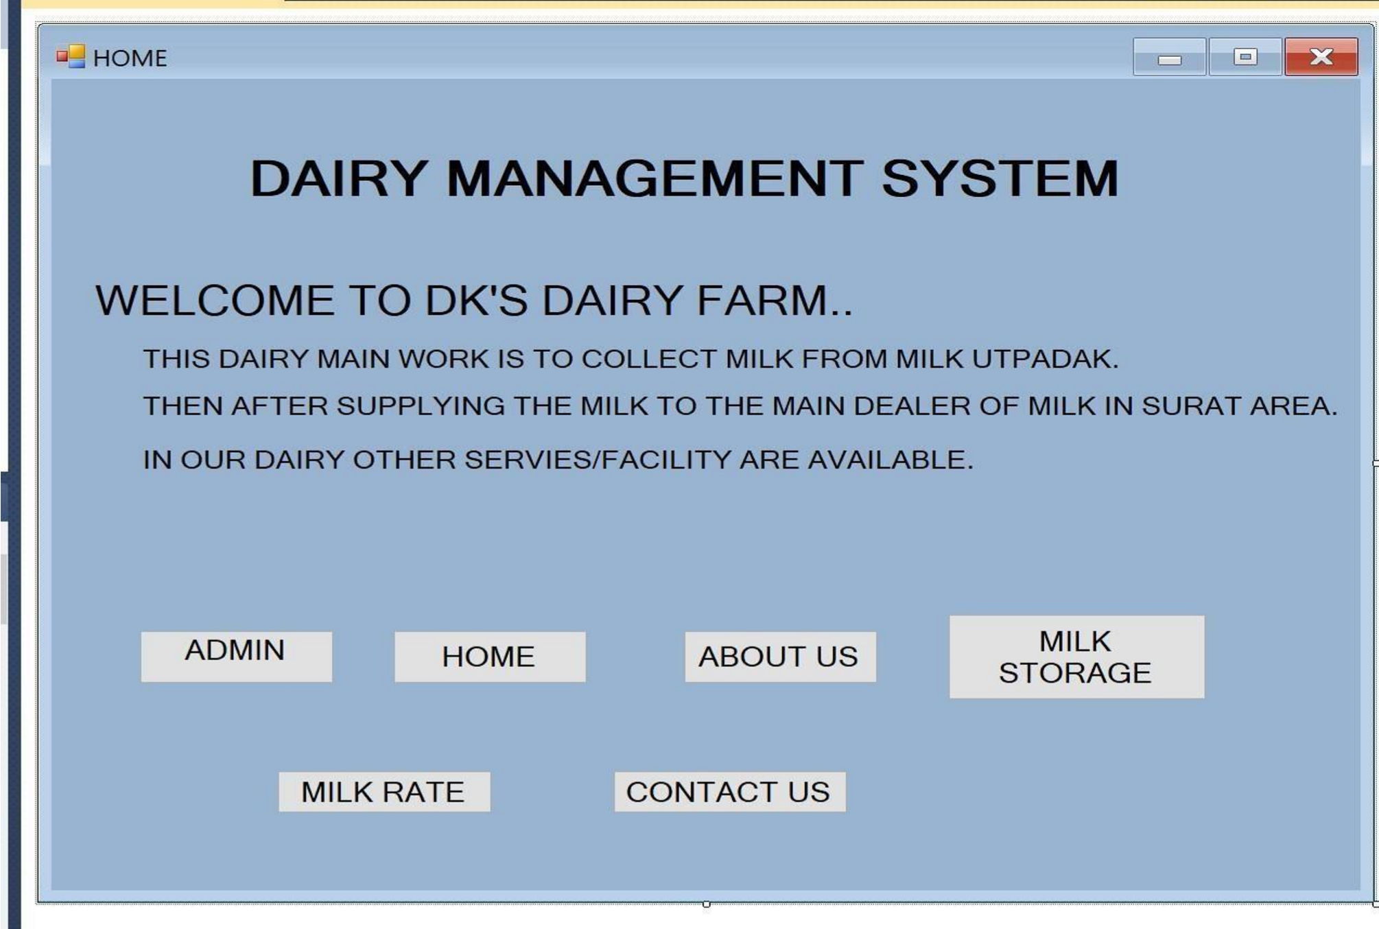

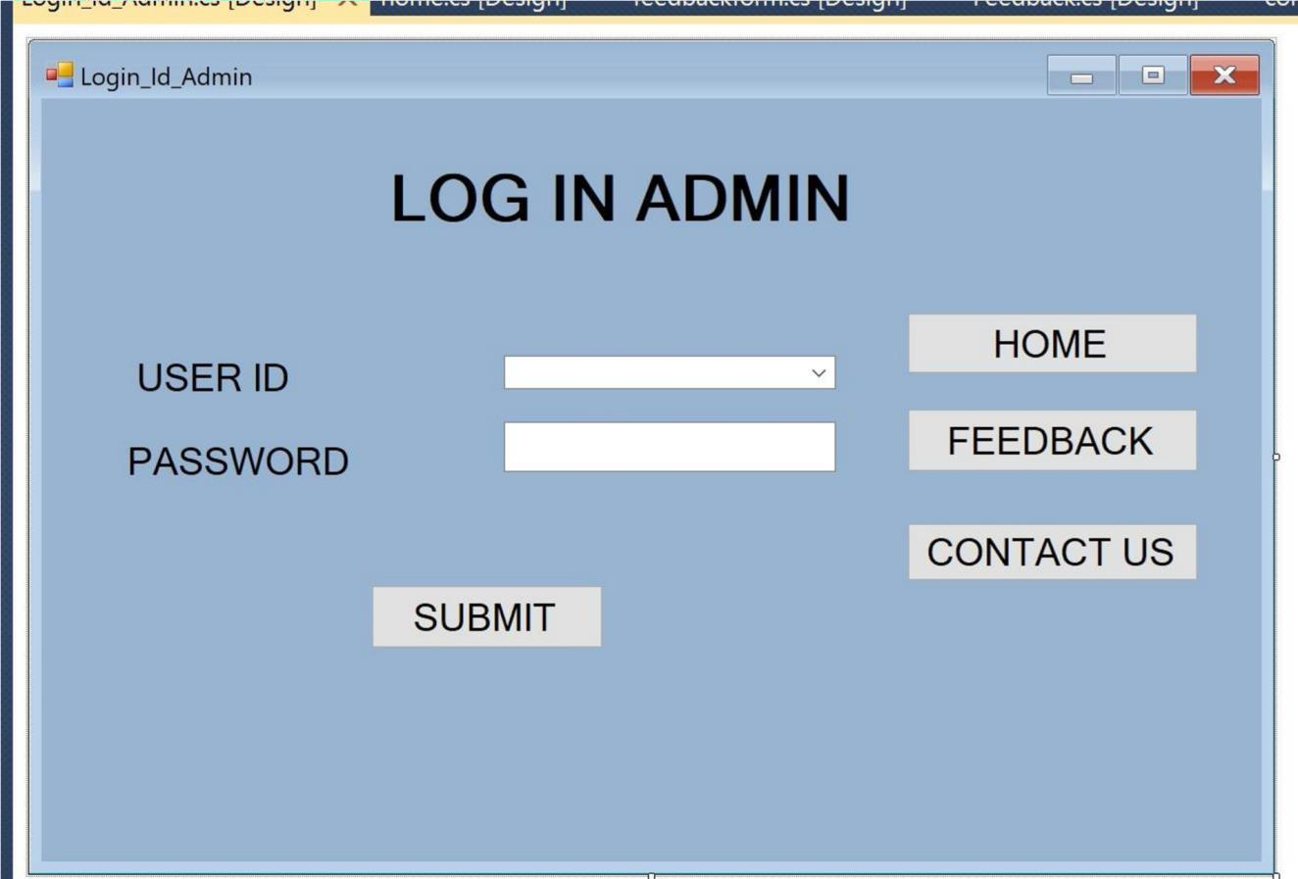

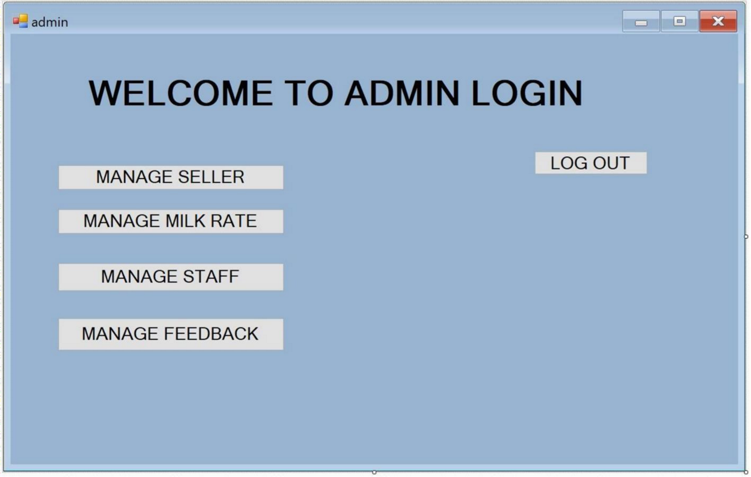

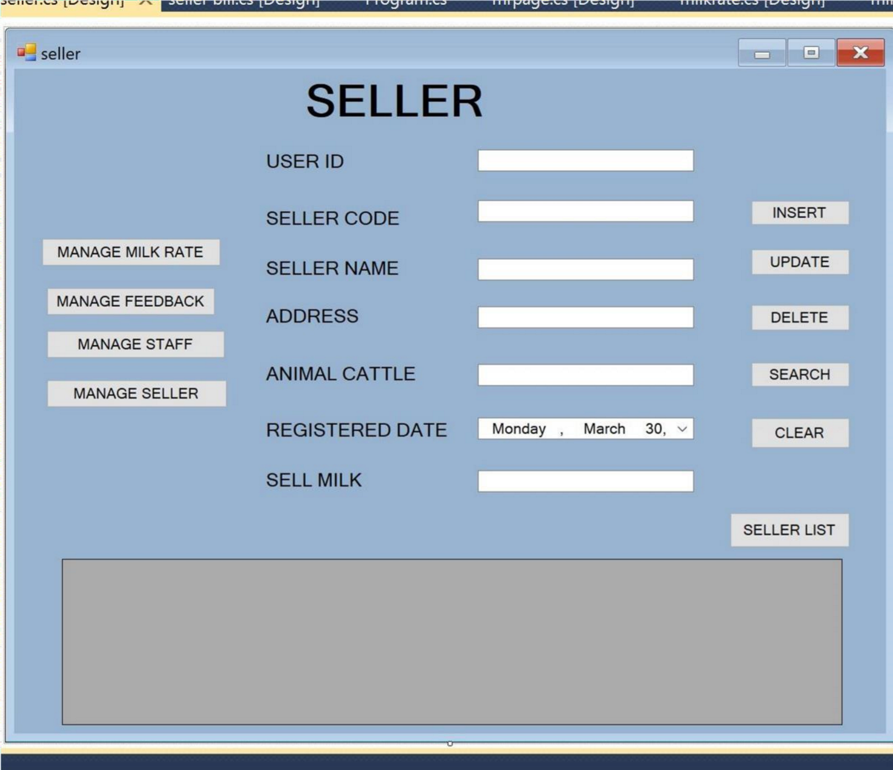

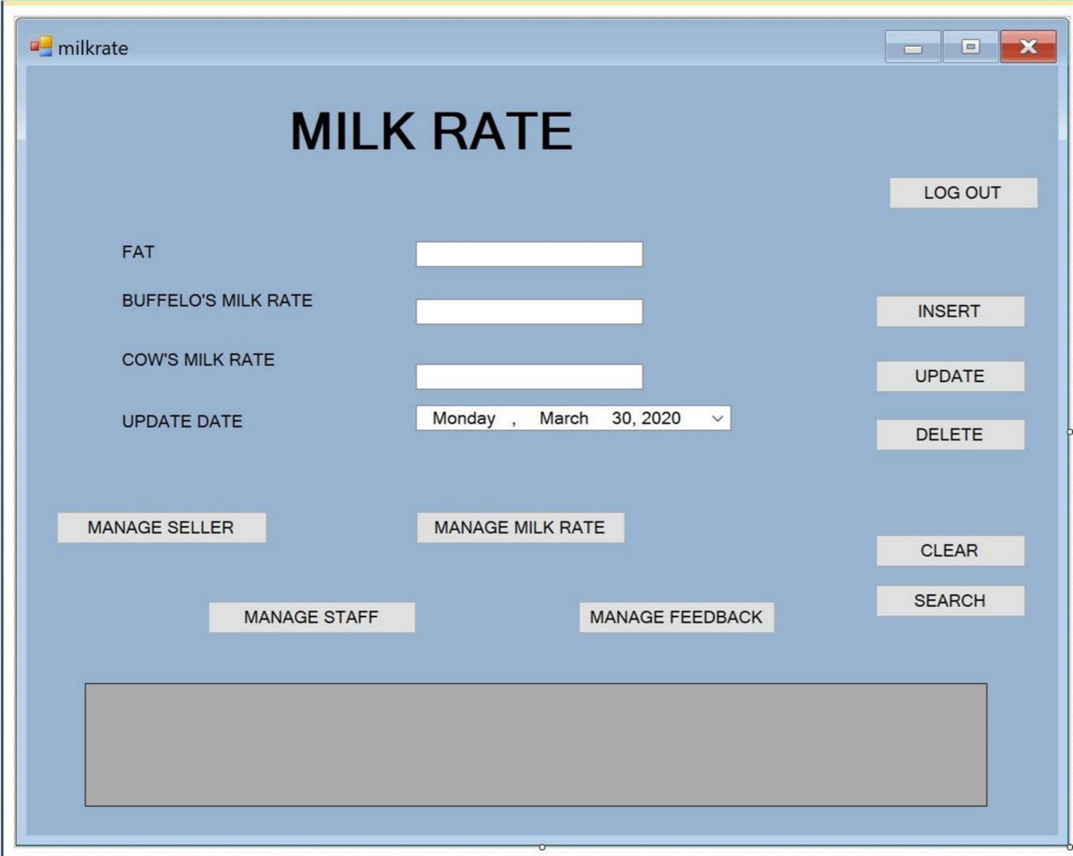

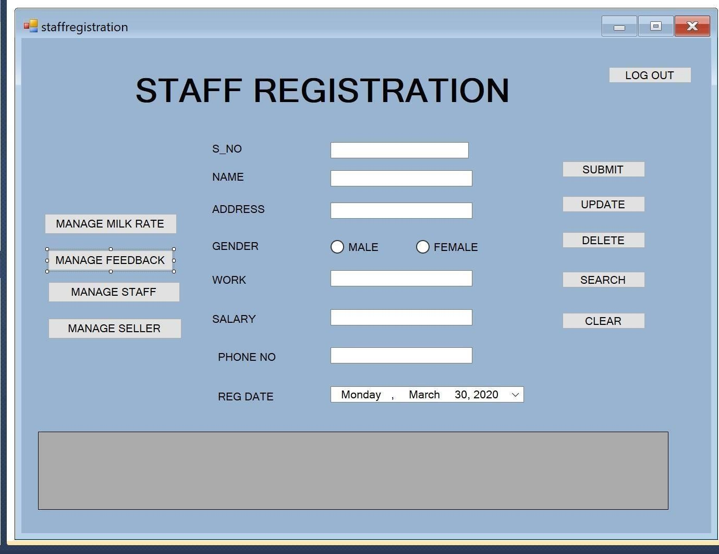

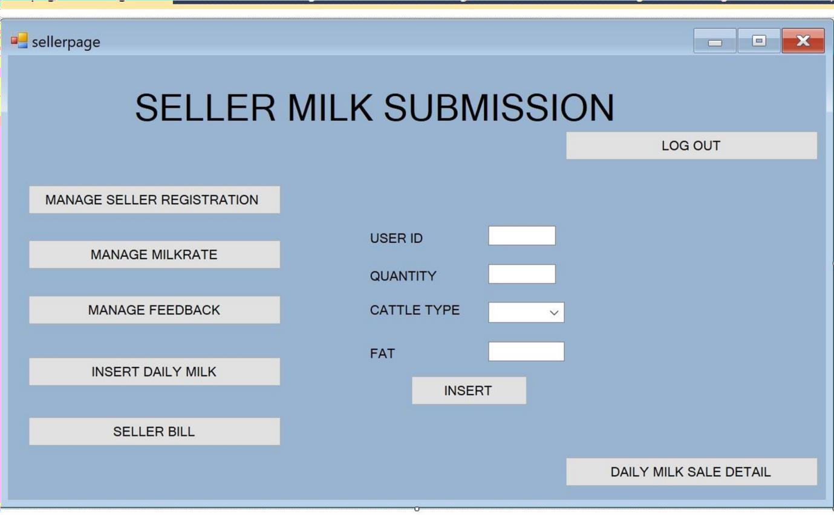

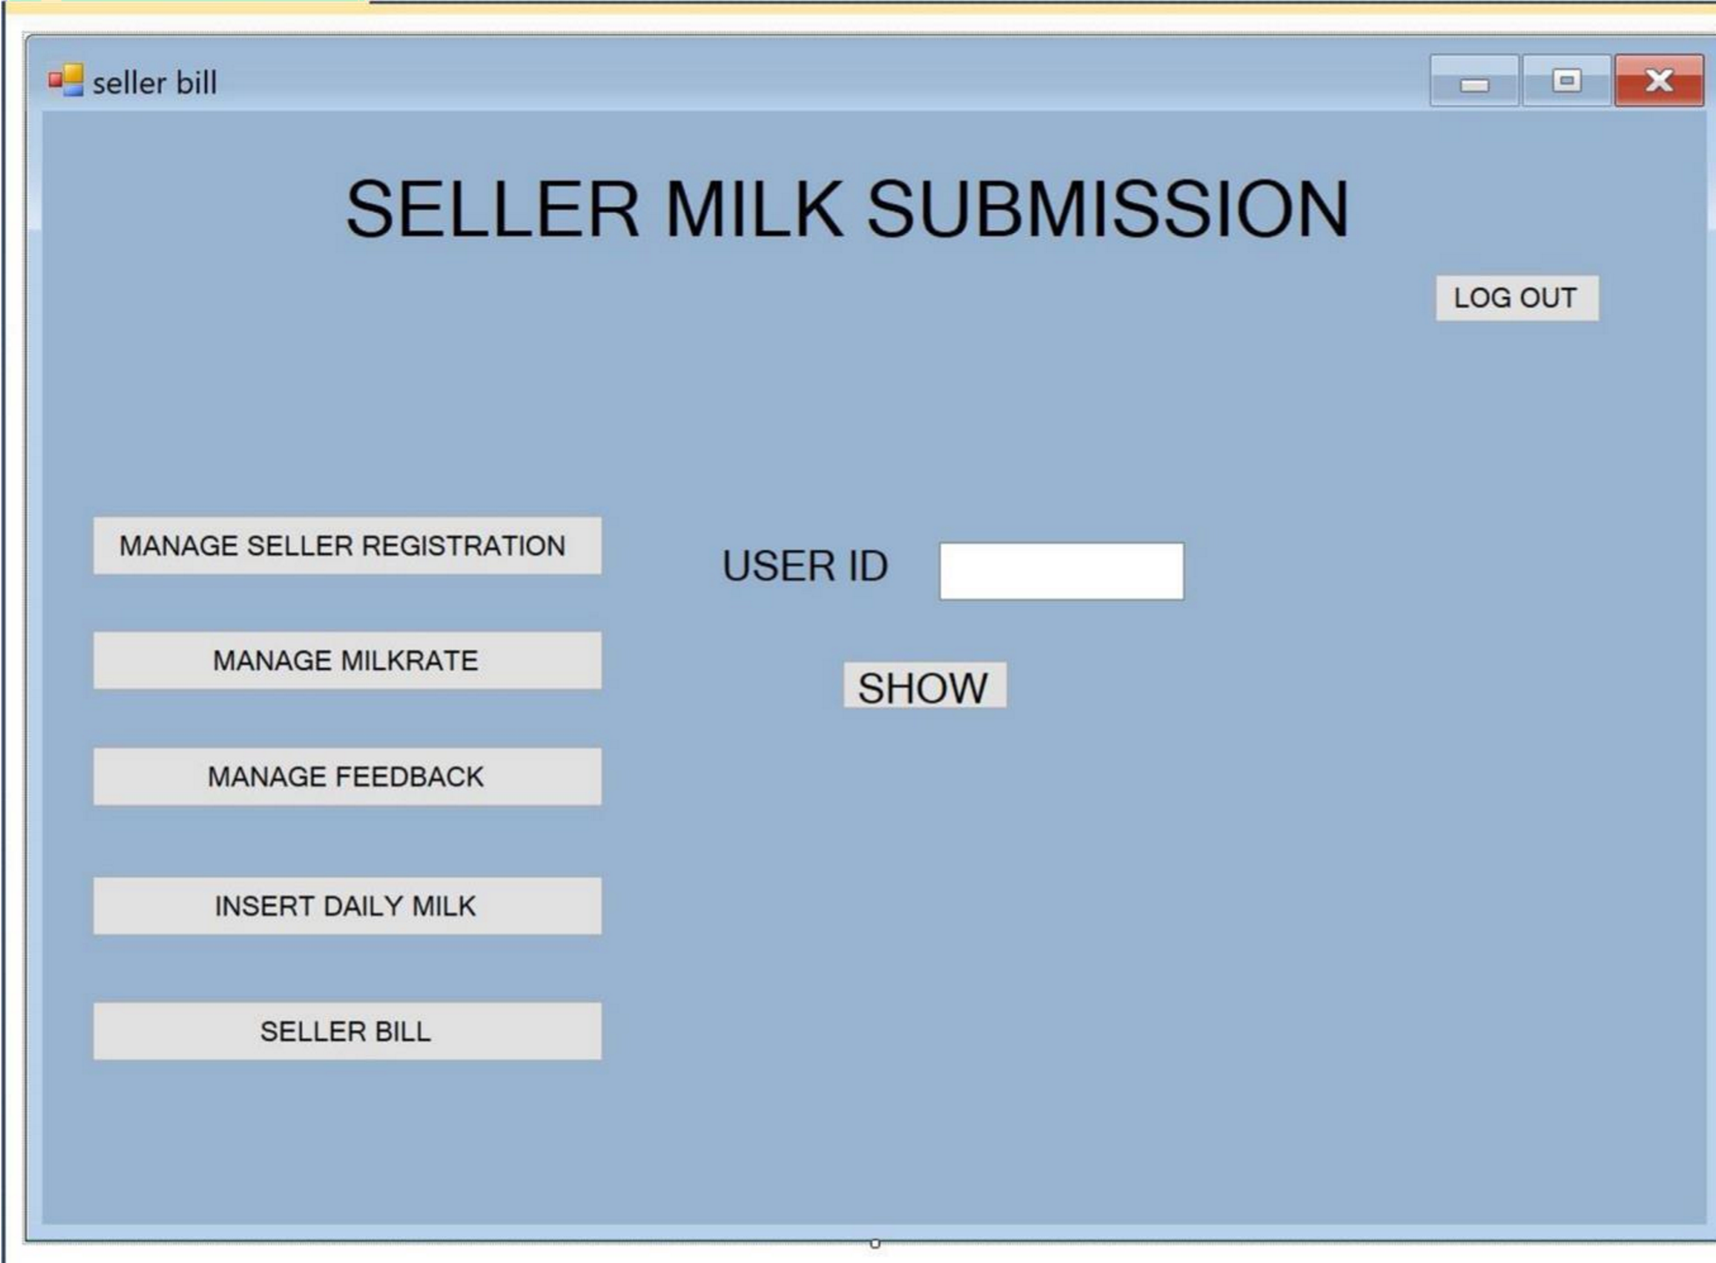

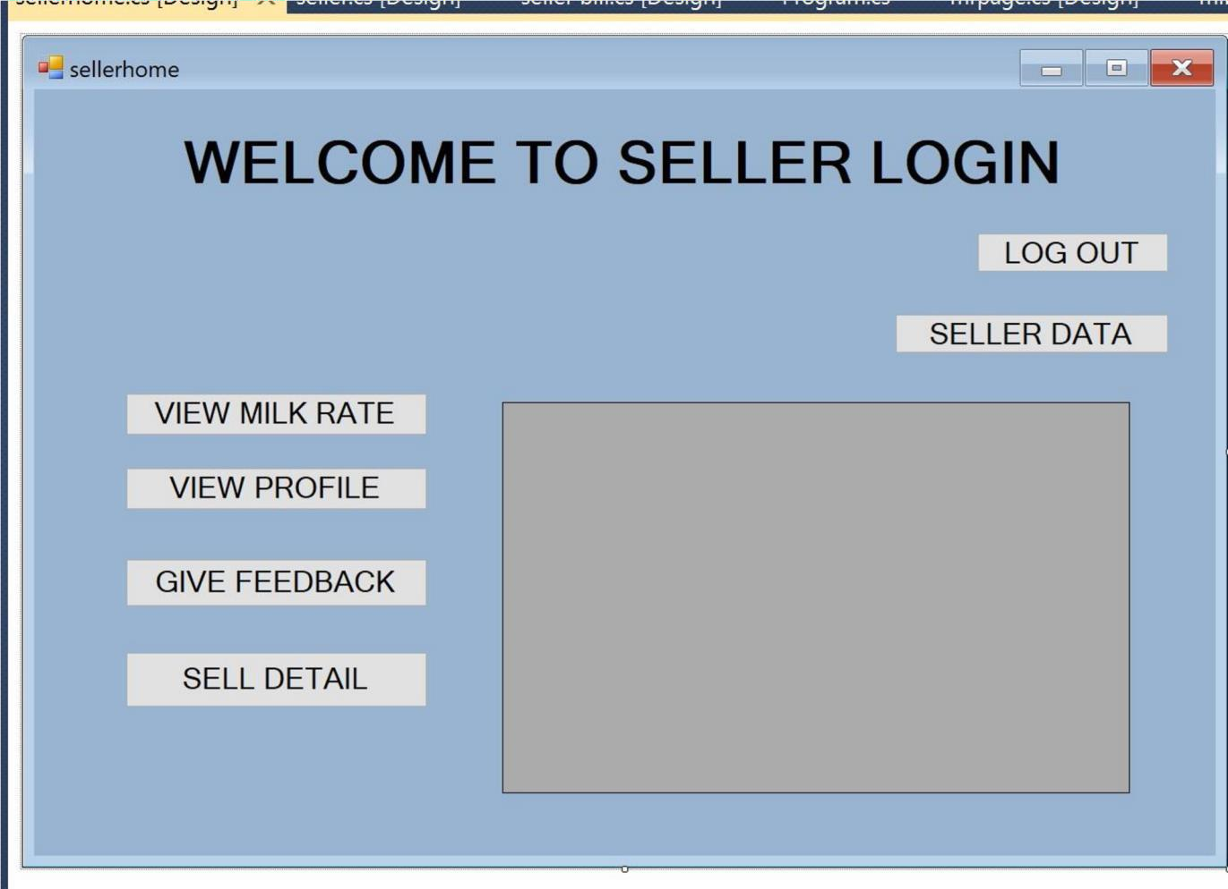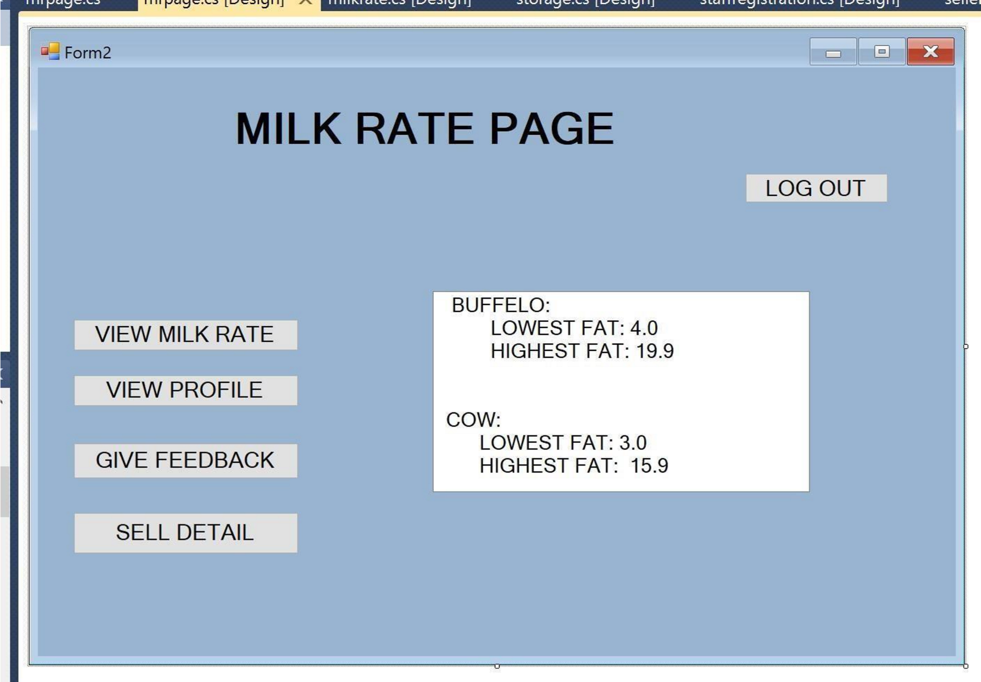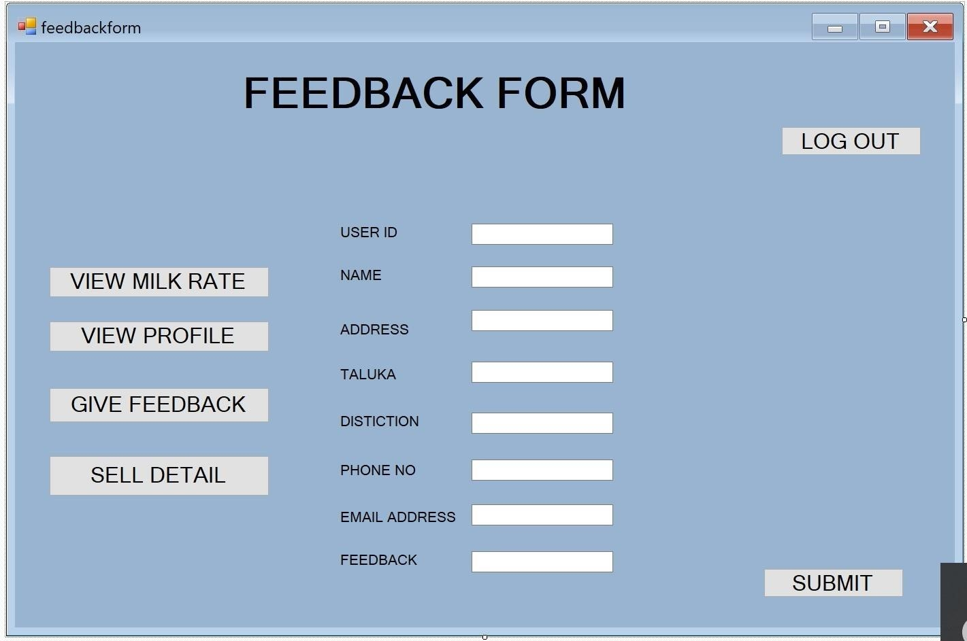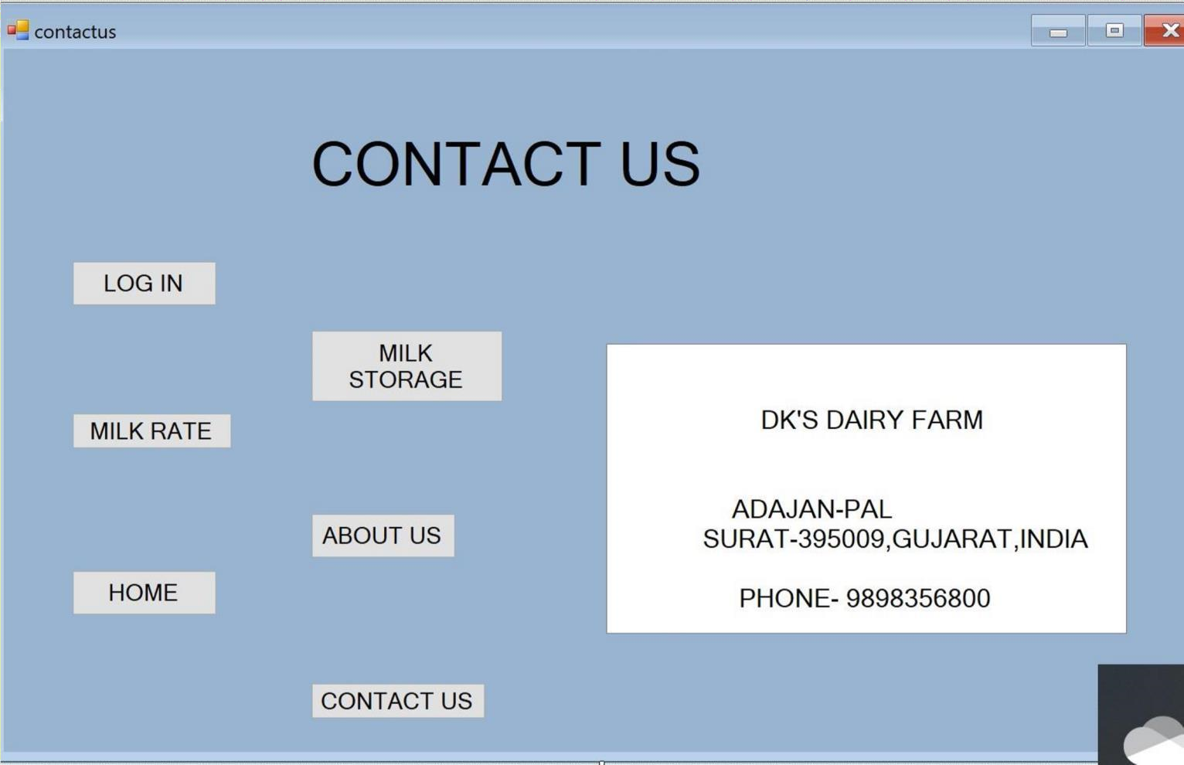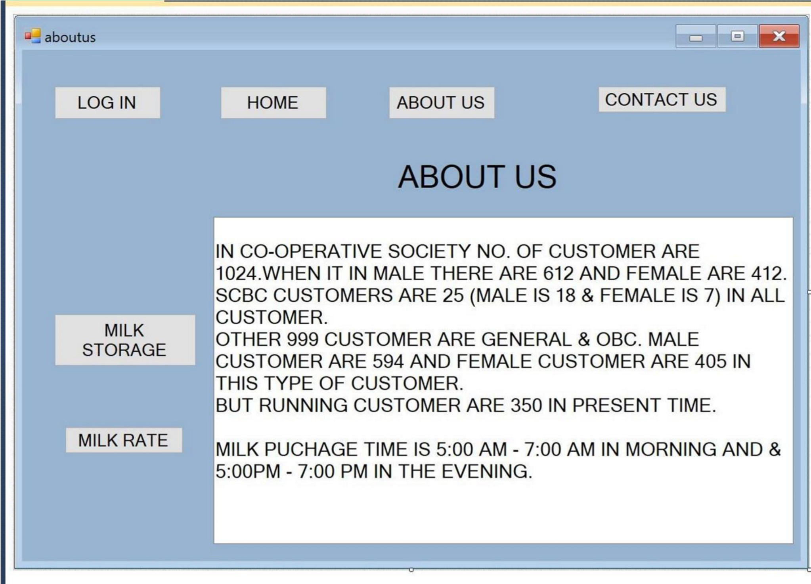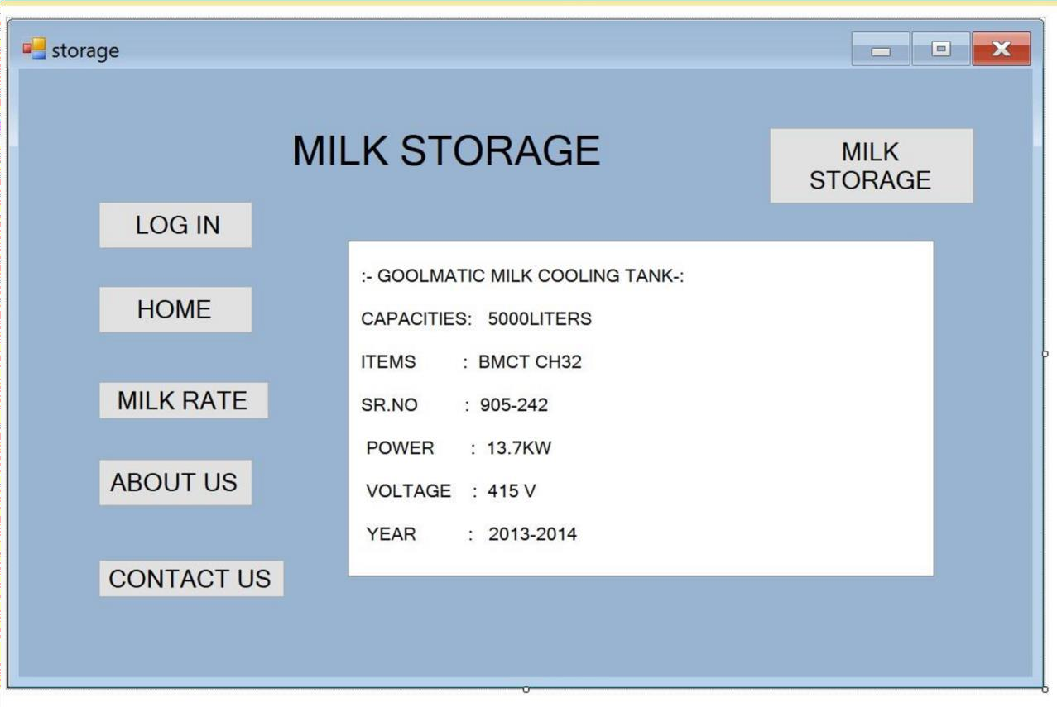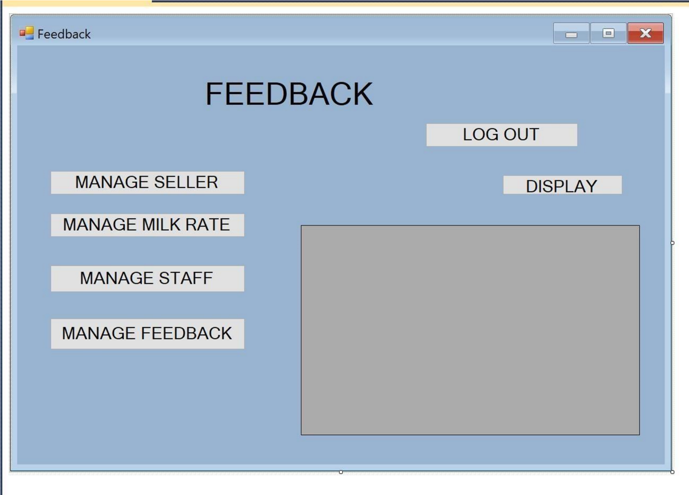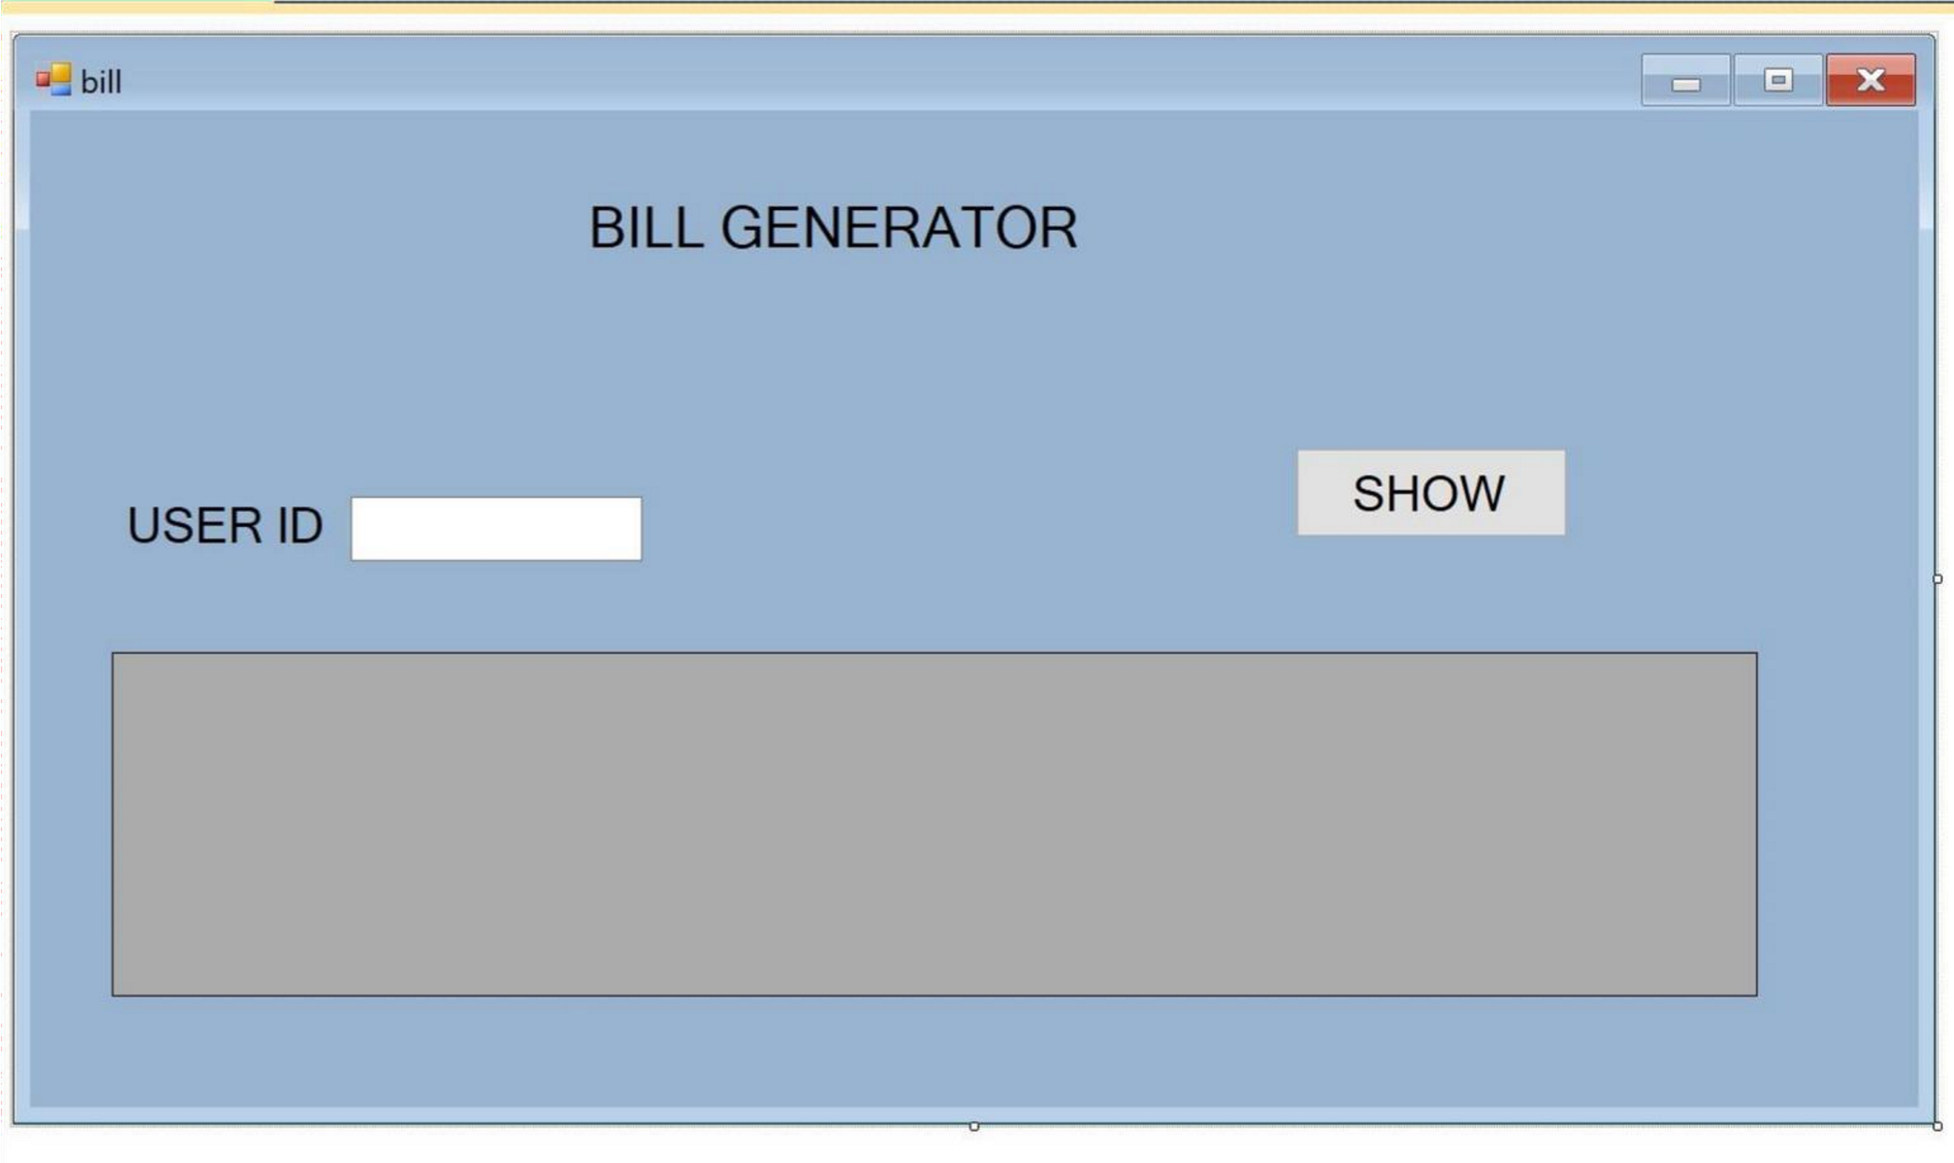

**Conclusion**

* + This system provide an easy way to operator for interact with database and manipulate the data in the database.
  + The operator can add, delete, update and search records in the database with ease.
  + This system will lead to paperless society and manage all the data.
  + It provide easy, accurate, unambiguous and faster data access.
  + This project is therefore, designed in order to minimize the day to day problem.

**BIPLIOGRAPHY**

BOOK REFERRED: • Book Name: PHP6 and My SQL •

Author Name: Steve Suehring, Tim Converse, and Joyce Park

Site Reffered :- www.w3school.com   